REVIEW
- Choose the odd one out:
- A. doll B. kite C. mom D. ball

- A. goal B. slide C. seesaw D. pilot

- A.mom B. dad C. sister D. brown

- A. doctor B. pilot C. pencil D. police officer

- A. pen B. eight C. book D. eraser

- A. face B. hands C. arms D. eyes

- A. car B. nurse C. doll D. ball

- A. one B. two C. eight D. pilot

- Choose the correct answer:
1.
  - car
  - ball
  - kite
2.
a. lion
b. nose
c. bear
3.
- ball
- hands
- bike
4.
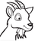
- cat
- dog
- goat
5.
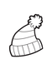
- hat
- egg
- train
6.
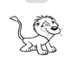
- dog
- lion
- ink
7.
- nose
- face
- apple

- Write
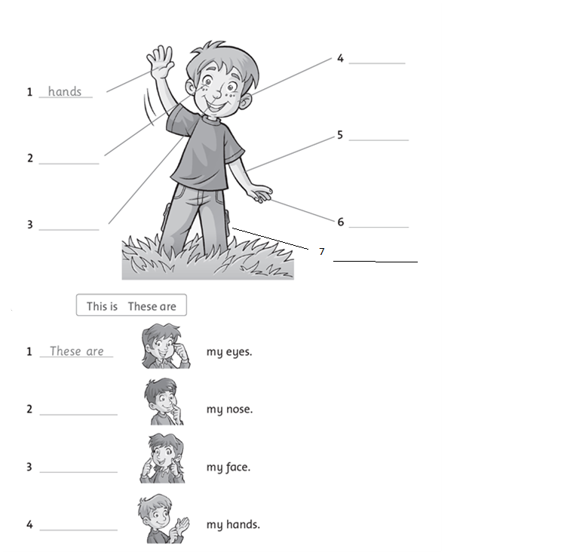

- Complete the sentences:
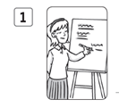 ______ a teacher.
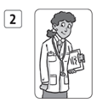_________a doctor.
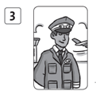_______a pilot.
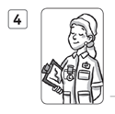_________a nurse.

Answer key
- Choose the odd one out:
1.B
2.D
3.D
4.C
5.B
6.A
7.B
8.D
- Choose the correct answer:
1.A
2.C
3.A
4.C
5.A
6.B
7.C
III. Write
- hands
- eyes
- nose
- face
- hands
- fingers
- legs
- These are
- This is
- This is
- These are
IV. Complete the sentences:
- She is
- She is
- He is
- She is

